Add testing,update new gantt chart, add dfd 1 and database schema in table of contents.

Some changes in introduction.

Mero School is a web-based school management system that aims to enhance the management of schools and colleges. The Mero School system is a powerful and flexible solutions that can be customize to meet the specific needs of individual schools. The system is web-based, which means that it can be access from anywhere and on any device with an internet connection. This makes it easy for teachers, students, and parents to access information .. The education system plays a critical role in shaping the future of individuals and society as a whole. However, managing schools and colleges can be a challenging task, especially with increasing student enrollments and administrative tasks. So, in order to address this issue we are developing this project. The purpose behind selecting this project was to address the challenges faced by schools and colleges in managing student and administrative data. Our research revealed that most schools and colleges still rely on manual systems, which are timeconsuming, error-prone, and can lead to data loss. This is where Mero School comes in, providing a comprehensive solution to automate routine tasks and improve operational efficiency. The implementation of Mero School is essential in the current educational environment, where schools and colleges are facing increasing pressure to improve the quality of education and administrative efficiency. Going digital is the best method as it allows for greater accuracy, efficiency, and accessibility. By implementing Mero School, educational institutions can streamline their administrative tasks, enhance communication, and focus more on the core aspects of education

\\SOME CHANGES IN METHODOLOGY

The Spiral model is used for the development of the Mero School web based school management system. We have choosen spiral model for the development of Mero School due to its iterative and flexible nature, which allows for constant feedback and adaptation to changing requirements. This model also emphasizes risk management, which is important for a school management system that handles sensitive information and requires reliable performance. The Spiral Model is a risk-driven approach to software development for identifying and mitigating risks throughout the development process. It can be useful for the development of Mero School website by helping to ensure that the website is delivered on time and within budget, and meets the needs of its users. The Spiral Model involves planning, risk analysis, prototype development, evaluation, development, deployment, and maintenance

GANTT CHART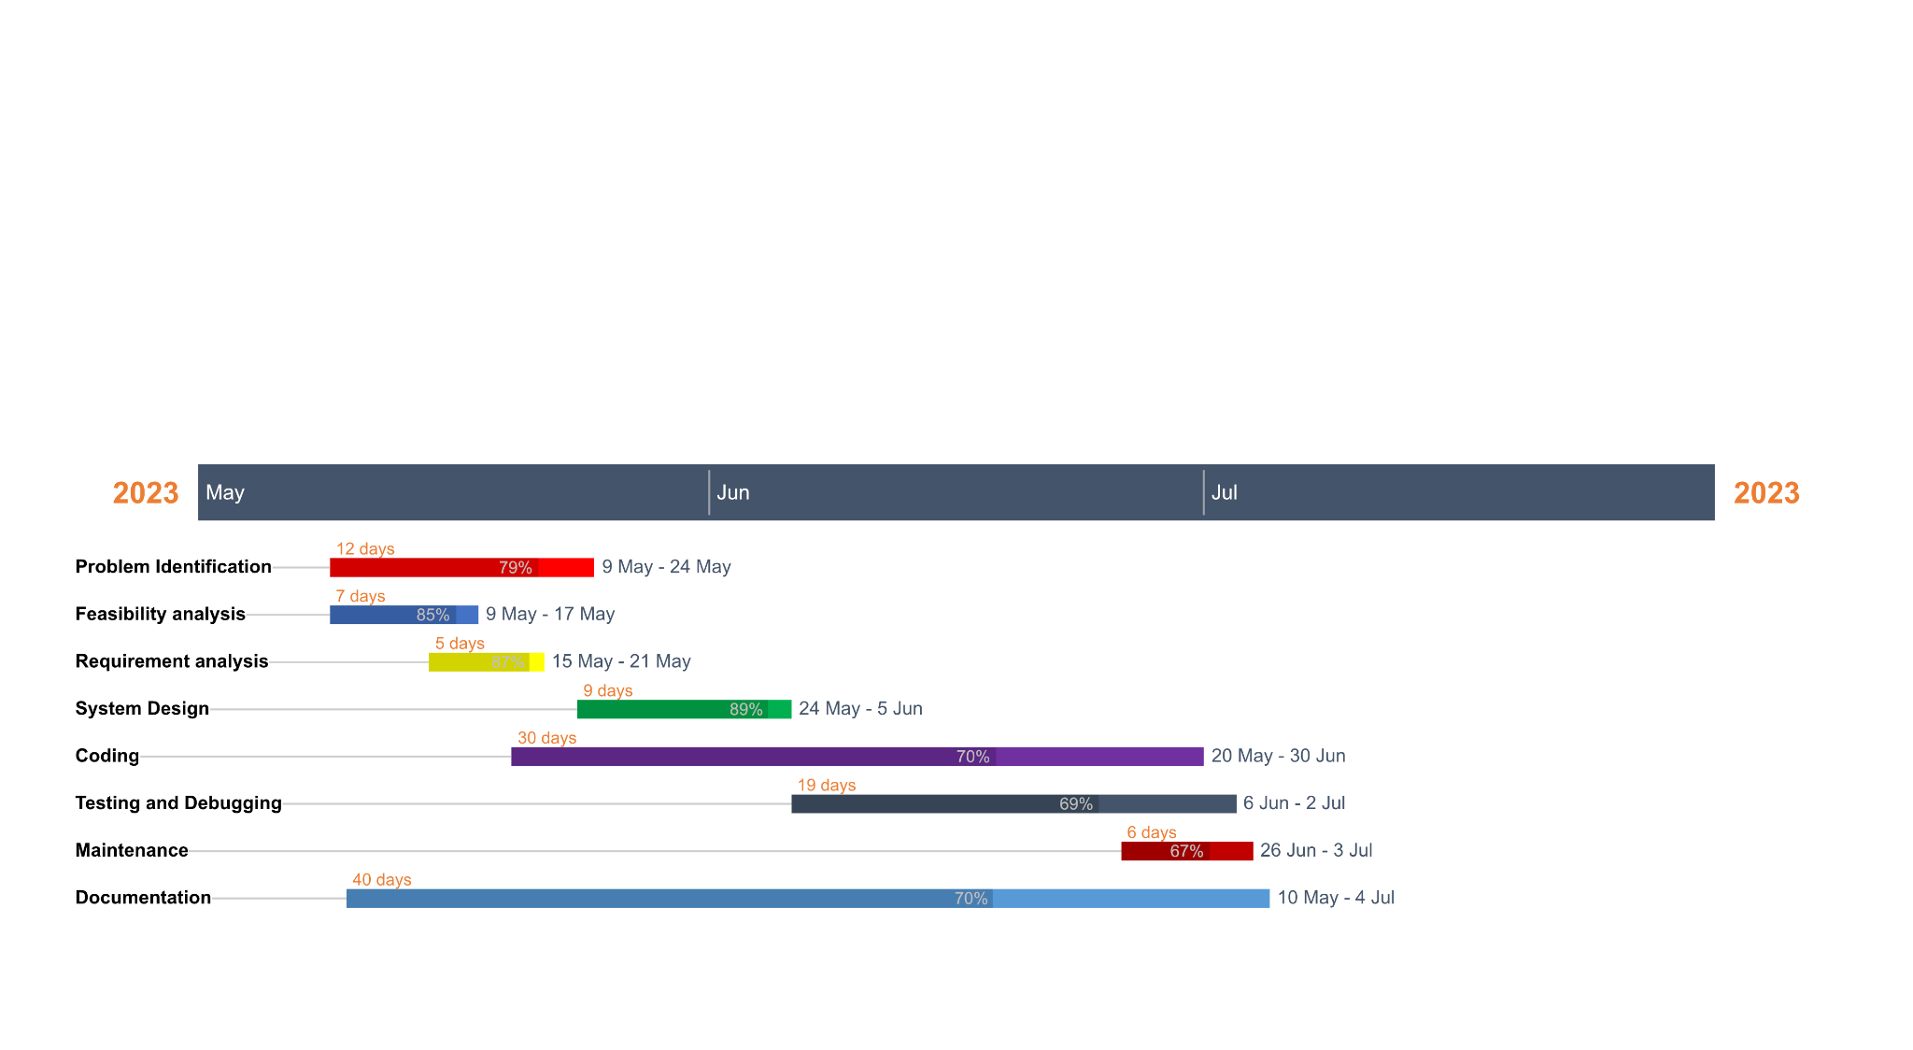

Database schema

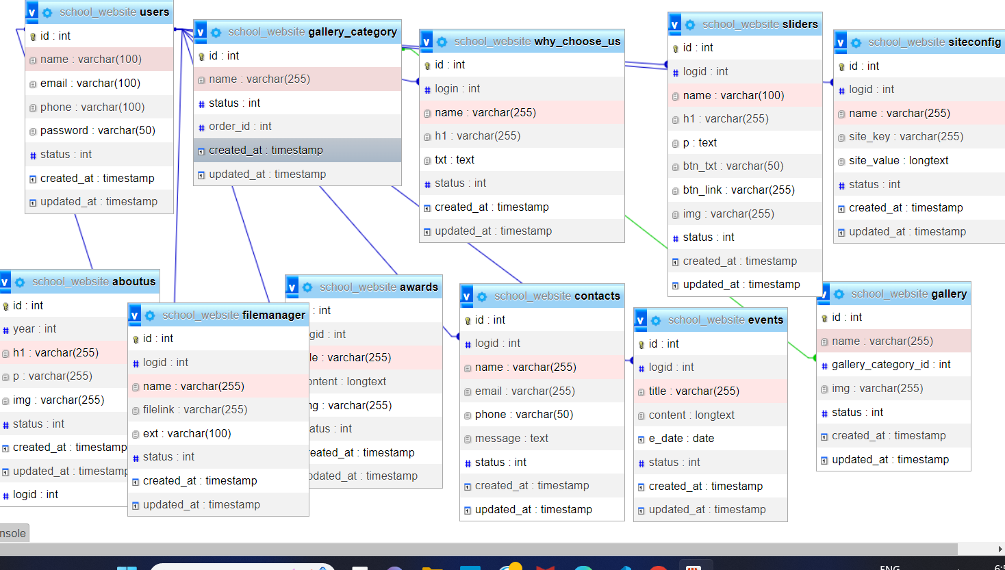

Progress Report: Mero School Management System

Mid Term Progress Report 1

Project Title: Mero School

Participants: [List the names of the project participants]

1. Draft Cover Page:

[Include a cover page with the following information:

- Mid Term Progress Report 1

- Project Title: Mero School

- Participants: [List the names of the project participants]]

2. Completed Tasks:

- Develop a database schema for the school management system.

- Design and implement the user interface for the system.

- Create a login and authentication module for administrators, and students.

- Implement the functionality to add, edit, and delete student..

- Develop a basic notice feature for users.

-Implement a complete site dynamic.

3. Tasks to be Completed:

- Enhance the reporting feature to provide more comprehensive and customizable reports.

To Implement the functionality to add, edit, and delete teacher.

- Implement a parent portal for parents to access their child's information and communicate with teachers.

- Enhance the user interface for better usability and aesthetics.

- Perform thorough testing and bug fixing to ensure the system's stability and reliability.

4. Bottlenecks:

- Limited availability of resources, such as hardware and software licenses, has slowed down the development process.

- Complex integration requirements between different modules have presented challenges that require careful planning and coordination.

5. Other Issues Hindering Progress:

- Inadequate documentation of requirements and specifications has led to ambiguity and misinterpretation during the development process.

- Communication gaps between team members and stakeholders have caused delays and misunderstandings.

- Unexpected technical issues and constraints have required additional time and effort for resolution.

- Adherence to project deadlines and resource constraints has impacted the allocation of development resources.

Note: This progress report is a draft and subject to further updates and modifications as the project progresses.